Webpage Design & Development

A comprehensive report using HTML5, CSS3 & JS

Student:

Aniket Nilegaonkar – 10525461

Suneet Maben – 10522921

Srikanth Shilesh Pasam - 10387794

Teacher:

Ehtisham Yasin

Course:

Web and Mobile Technologies (B9IS124)

Table of Contents

Introduction 3

Background 3

HTML 3

CSS 4

JS 4

Design Approach 5

Sitemap 6

Website Layout 7

Phase 1 – Home Page 7

Phase 2 – Info Page 7

Phase 3 – Responsive Design 8

Phase 4 – JavaScript 8

Proof of Concept 10

Bibliography 15

Appendix 16

# Introduction

This project aims to develop a website for a car adverts business. The website is required to show the images and details of various cars. Users should be able to navigate through the website viewing the details of any car they like. They should also be able to search for any particular car of their choice based on the make/model and manufacturing year. Finally, if the user is interested in any car, they should be able to contact the business through a form.

In order to develop this website, we will be using three major web development technologies:

* HTML – HyperText Markup Language
* CSS – Cascaded Style Sheets
* JS – Java scripts

# Background

## HTML

HTML is a markup language that helps define the structure of the content. This project utilizes HTML 5. HTML 5 lets us do almost anything on the website from displaying text, animating content, playing videos or music and also works across all devices from PC’s to smartphones (Marshall, September 28)

The main parts of HTML are the

* Opening and closing tags
* Content
* Elements

Everything in HTML written between opening and closing tags, which define the starting and ending of the content written within it. Elements are used to define the content and placed it within the opening and closing tags. HTML files are saved with the extension ‘.html’ (*HTML basics*, no date).

## CSS

CSS helps us define how the content in HTML is to be displayed. CSS helps make designing websites easier as it can define multiple elements together. A CSS syntax is made up of:

* Selector
* Declaration

The selector is used to reference a particular element or attribute from the HTML and define the styling for it (*CSS Syntax*, no date).

CSS can either be written within the HTML file itself using the '<style>' tag, but usually, in practice, it is written as a separate file and stored with the extension '.css.' This file is then linked to its corresponding HTML file using the link stylesheet element and placed within the head of the file.

## JS

JavaScript is the programming language for the web. It can be used to calculate, manipulate, and validate content and fields in HTML and CSS. The browsers JavaScript engine executes the JavaScript after loading the HTML and CSS onto the webpage (*What is JavaScript?*, no date).

JavaScript files are stored using the extension ‘.js’. Furthermore, they are referenced in the HTML file using the script element within the head or body of the file.

# Design Approach

The first step in developing any website is to design the layout, structure, and navigation. Since this website is required by a car dealer to enable him to reach out to potential customers, it can be designed based on a typical e-commerce website layout. It should primarily house three units:

* Inventory Catalogue
* Product Description
* Customer Interaction Space

The website needs to be able to display all the vehicles available with the dealer. In this way, the customer has the most options. A search feature makes it easier for the customer to search for a specific vehicle.

The user should also be able to read in more detail about a vehicle. Such a feature will help customers reach a decision and build business for the dealer.

Finally, when a customer is interested in any particular vehicle, they should be able to contact the dealer quickly.

Together, all these components will need to make user interaction easier, all the while letting the dealer showcase his vehicles, thus increasing reachability and profitability through this website.

# Sitemap

The sitemap below highlights the various components and how the user can navigate through it:

*Fig1. Sitemap*

# Website Layout

With the basic structure and sitemap finalized, we can move on to designing the layout and its elements in detail. The website layout consists of four phases.

## Phase 1 – Home Page

The home page is a crucial factor in building the first impression of the website. The user should have a clear idea of how to use the different elements within the webpage. This page should be able to portray the vast array of options available with the dealer while also not overwhelming the customer with too much content. All these factors influenced the home page design. The home page has two sections:

* Landing Zone (Hero Section)
* Vehicle Catalogue (Cars Section)

The landing zone is the first section that shows up when visiting the webpage. It contains the logo of the dealer on one side and sign-in option on the other. These two make up the navigation bar. Below is the space for the customer search field. The search field lets the customers search for a car based on a criterion they have in mind. This entire landing zone has an attractive background video playing in a loop. There is also the option for the customer to pause the video if they choose to.

As the customer scrolls down, they will be able to see the cars section. The cars section is the catalog of all the vehicles available with the dealer. There is a frame for each car that is highlighted and animated as the user scrolls across them. The front of the display has a small picture of the vehicle, followed by its details. As the customer points to a car they are interested in, the frame rotates and shows the ‘Learn More’ button. They can tap it, which will lead to a new webpage showing the description of that particular vehicle in more detail.

## Phase 2 – Info Page

The info page is the second HTML page of the website. The primary purpose of this page is to provide a detailed description of a vehicle to help the customer decide. The page loads up the details and description of the car which the user has selected. There is only a single HTML code but the data within it is manipulated using JS depending on user choice.

The page layout is four parts. They are:

* Navigation Bar
* Vehicle Images (Slideshow Section)
* Vehicle Details (Info Section)
* Contact Form (Popup Class)

The navigation bar is similar to the one on the home page. It has a logo on the left and sign in and contact us on the right. The images of the vehicles then follow this. The customer can scroll the images. Below this are the details and description of the vehicle. They will help provide insight to the customer about the vehicle. The last section of the page gives the customer the option to return to the homepage or contact the dealer.

On clicking the ‘Contact Us' button, a popup window appears with the form the customer needs to fill in order for the dealer to get back to them. The name, email, and phone number of the form is mandatory without which the form will not get submitted.

## Phase 3 – Responsive Design

In the current age where more than half of the internet traffic is from the mobile, it is required for a website to be responsive (‘What Percentage of Internet Traffic Is Mobile in 2019?’, 2019).

One of the critical factors to keep in mind when trying to make the website responsive is to make sure the user experience remains constant while making the webpage mobile/tablet friendly.

The website layout has been modified to handle screen sizes of various devices using the media query element in a CSS file. By modifying the sizes of font, margins, padding, and repositioning the slides, the website can be transformed to look attractive across all devices.

Along with making the website responsive, it should also be made compatible with the various browsers in the market.

## Phase 4 – JavaScript

With all the elements of the webpage structured and layout finalized, we can move to coding the JavaScript for the website. The JS element is at six places, which are:

* Populating Car Details (Start ())
* Background Video Playback (Playback ())
* Search (Set_car_info_on_pop_info ())
* Car Picture Slideshow (Showslides ())
* Collecting User Data from Contact Us Form (Message ())
* Database for Storing all the Info

Using JS in designing webpages makes the webpage smarter. Instead of statically entering all the information on the webpage inside the HTML, we can have JS populate them, which makes scaling up and upgrading the webpage easy. The HTML page displays the generic elements while JS inserts specific car data, which can keep changing as the business progresses. Whenever the dealer needs to update his catalog, they will need to update one file, and JS takes care of populating the new information on the same HTML page.

# Proof of Concept

After deciding the layout, the final step would be to host the website. Adding a Google Tracking ID enables the dealer to track how the users are accessing the webpage actively, location of access, and which page they are visiting more than the others. Google Analytics will give valuable data for the dealer to decide how to adapt the website based on customer usage.

*Fig2.Home Page*

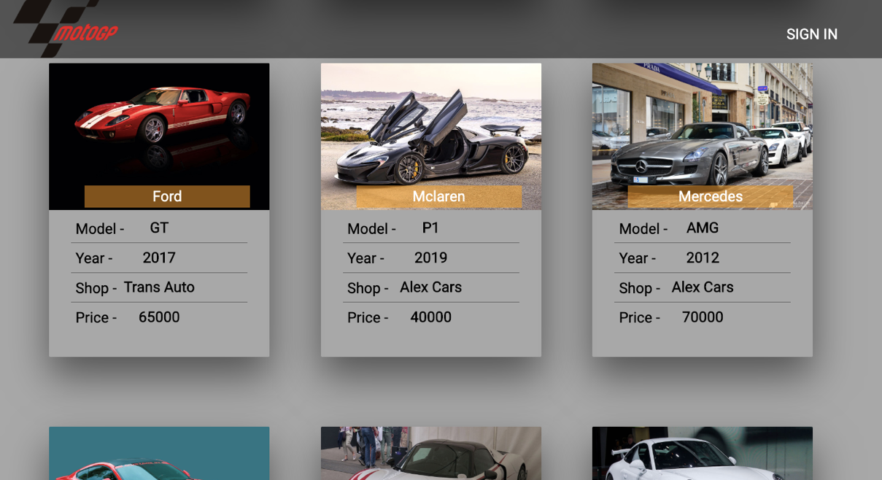

*Fig3.Inventory Section*

*Fig4.Info Page*

*Fig5.Description Section*

*Fig6.Contact Us Form*

*Fig7.Responsive Home Page*

*Fig8.Responsive Inventory Section*

*Fig9.Responsive Info Page*

*Fig10.Responsive Contact Us Form*

# Bibliography

*CSS Syntax* (no date). Available at: https://www.w3schools.com/css/css_syntax.asp (Accessed: 19 November 2019).

*HTML basics* (no date) *MDN Web Docs*. Available at: https://developer.mozilla.org/en-US/docs/Learn/Getting_started_with_the_web/HTML_basics (Accessed: 19 November 2019).

Marshall, C. (September 28) *HTML5: what is it?*, *TechRadar*. Available at: https://www.techradar.com/news/internet/web/html5-what-is-it-1047393 (Accessed: 19 November 2019).

*What is JavaScript?* (no date) *MDN Web Docs*. Available at: https://developer.mozilla.org/en-US/docs/Learn/JavaScript/First_steps/What_is_JavaScript (Accessed: 19 November 2019).

‘What Percentage of Internet Traffic Is Mobile in 2019?’ (2019) *Hosting Tribunal*, 4 April. Available at: https://hostingtribunal.com/blog/mobile-percentage-of-traffic/ (Accessed: 19 November 2019).

# Appendix

*Website source code files available at:*

<https://github.com/srikanthshileshpasam/caradvertsweb.github.io>

*Website domain:*

<http://srikanthshileshpasam.com/>